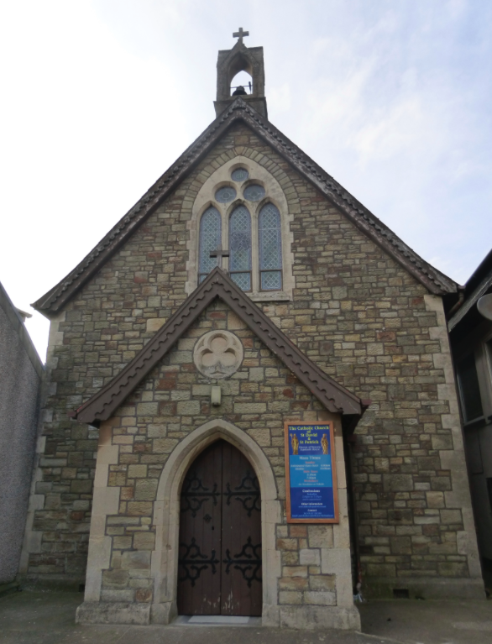 | St David and St Patrick’s Catholic Parish
 | St David and St Patrick’s Catholic Church,  9, Fountain Row, Barn Street,  Haverfordwest. SA61 1SX. | Immaculate Conception Catholic Church,  Church Street, Narberth.  SA67 7BH.
Parish Priest: Rev. Liam Bradley. Tel. 01437 762284
Parish Deacon: Rev. Tony Lawrence. Tel. 01437 454381
Parish email: stdavidandstpatrick@gmail.com
Website: www.stdavidandstpatrick.org

Mass times for the week ahead: 24th – 30th October.  Week 30 of liturgical year C.  Mon No Mass.  Tue No Mass. Six Welsh Martyrs and Companions  Wed 10:00am Eucharistic Service at Haverfordwest.  Thur No Mass  Fri 10:00am at Haverfordwest – Sts Simon & Jude  Sat 6:00pm Haverfordwest – Anticipated Mass of Sunday  Sun 10:00am Haverfordwest; 5:00pm Narberth | Saint of the Week The Six Welsh Martyrs are part of the group of Forty Martyrs of England and Wales who were canonized by Pope Paul VI in 1970. Recognised as being of heroic virtue from the time of the Reformation, they died between the years of 1535-1679. On May 4th we celebrate their beatified companions too. The Six Reformation Martyrs of Wales are St Richard Gwyn a School Master executed on Oct 17th 1584, St John Jones hanged on July 12th 1589, St John Roberts hanged on December 10th 1610, Sts Philip Evans and John Lloyd killed together at Cardiff on 22 July 1679 and St David Lewis Hanged on 27th August 1679.
World Mission Sunday is this weekend and the Holy See asks us to take a second collection to support missionary dioceses. Many of us support the missionary work of the Church throughout the year by collecting in the ‘Red Boxes’. This year we raised £968 so well done to all.

November Dead List November is the traditional month of the holy souls when we pray for our dead and remember them at Mass. If you would like your loved ones to be remembered at our Masses, then please take an envelope from the porch to return your list of names and any Mass offering you wish to make. The names shall be entered into the Book of the Dead and placed near the altar at every Mass.

Advance Notice of Dates: • November 1st is the Solemnity of All Saints and is a Holy Day of Obligation. There will be Mass at 2pm at Withybush Hospital and at 7pm at Narberth. • November 5th is our Youth Day at Ffald-y-Brenin with an evening Barbeque. • November 20th the youth will lead the Chaplet of Divine Mercy to close the ‘Jubilee year of Mercy’ • December 8th – the feast of the Immaculate Conception – at 7pm we will welcome the Rev. Dr Bruce Burbidge who will give a lecture on Mary. Fr Bruce is currently a lecturer at Oscott College, our seminary in Birmingham, and formerly taught Philosophy and Latin at the Pontifical Gregorian University in Rome. •December 13th will be the evening for our Advent Penitential service.

Missing Does anyone have the parish’s red and black extension cable? It has been missing for some weeks now so, if you’ve forgotten to return it, please can we have it back. Thank you.

Mary Immaculate School It’s half-term holiday this week so, if you’re a pupil or staff member, take some time off to get a good rest! Should you ever need to contact the school the phone number is: 01437 762324, and the address is: Mary Immaculate Catholic Primary School, Merlin’s Terrace, Haverfordwest. SA61 1PH. You can email too on head.maryimmaculate@pembrokeshire.gov.uk.

Hospital Cover I shall not be available for a few days next week but Deacon Tony will be available in the parish. He will lead a Service of the Word and Eucharist at the normal Mass time on Wednesday. If a priest is needed in an emergency at the Hospital, then please ask the nurses to make contact with Fr Valentine through the Switchboard. Fr Valentine is based in Pembroke Dock and his contact numbers are 01646 682079/07449 644861.

Gregory Beckett has settled in well to life in the Seminary in Spain and sends his best wishes. For those who have Facebook you will have already seen his message – for those who do not, rest assured that he’s very content in what he’s doing and sends his warmest regards to all.

Getting Married If you’re hoping to get married soon then Congratulations and please let me know as soon as possible. If you’re a Catholic who’s not getting married within the Church, then your marriage wont be recognised by the Church. However, recognition may be given if the Church knows, ahead of time, of your intention to marry in another ecclesial community or faith group. To marry outside the Church and have the marriage recognised requires a ‘Dispensation form Canonical Form’. If you think you may need this dispensation, then please speak with Fr Liam.

Will you find one moment this week to pray for those of our parish who are ill? Including, Annie Carter, Mercedes Davies, Peter Fowler, Bryn Hancock, Anne Harding, Janet Jenkins, Mary Philips, Indra Singh, Yolanda Servini, Teresa Thomas, Toby Williams.

