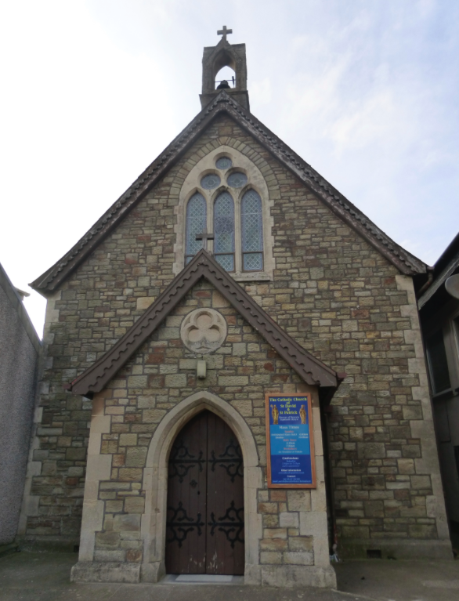 | St David and St Patrick’s Catholic Parish
 | St David and St Patrick’s Catholic Church,  9, Fountain Row, Barn Street,  Haverfordwest. SA61 1SX. | Immaculate Conception Catholic Church,  Church Street, Narberth.  SA67 7BH.
Parish Priest: Rev. Liam Bradley. Tel. 01437 762284
Parish Deacon: Rev. Tony Lawrence. Tel. 01437 454381
Parish email: stdavidandstpatrick@gmail.com
Website: www.stdavidandstpatrick.org

Mass times for the week ahead: 31st – 06th November  Week 31 of liturgical year C.  Mon 10:00am at Haverfordwest with Exposition and,  7:00pm All Saints’ Day Vigil (Halloween) Mass at Haverfordwest.  Tue 10:00am at Haverfordwest and 7:00pm at Narberth - All Saints’ Day Mass.  Wed 10:00am Mass at Mary Immaculate and 7:00pm at Narberth – All Souls’ Day Mass  Thur 10:00am at Haverfordwest – St Martin de Porres  Fri No Mass  Sat 6:00pm Haverfordwest – Anticipated Mass of Sunday  Sun 10:00am Haverfordwest; 5:00pm Narberth | Saint of the Week St Martin de Porres OP (1579-1639) was born in Lima as an illegitimate son of a nobleman and an African freed slave. He spent some time with a barber and surgeon to learn medicine but he found the life of prayer more attractive. Owing to his mixed parentage, he was initially not allowed to enter the Dominican convent but, in exchange for menial tasks as a volunteer, he was able to wear the habit (in art he is often shown holding a sweeping broom). Later in life, as a full friar, he ran the convent’s infirmary and was noted above all for his care of the sick putting charity first and foremost. He’s the patron saint of Peru, barbers and public health workers.
Holy Day of Obligation The Solemnity of All Saints’ Day is, like every Sunday, a Holy Day of Obligation where there is an expectation that all Catholics will bear witness to their faith by celebrating the joy of the Saints. Unless there is some grave reason such as illness/infirmity then all should attend Mass on this day. Mass times may be found above and the vigil Mass on Monday evening fulfils the obligation.

November Dead List November is the traditional month of the Holy Souls when we pray for our dead and remember them at Mass. If you would like your loved ones to be remembered at our Masses, then please take an envelope from the porch to return your list of names and any Mass offering you wish to make. During the month, all weekday Masses will be offered for the Holy Souls and the names submitted will be remembered at every Mass. The names shall be placed on the Lady Altar where votive lamps may be lit and the Book of the Dead which lists the deceased of our parish will be placed near the altar at every Mass.

British Summer Time Ends Don’t forget that on Saturday night British Summer Time will once more revert to Greenwich Mean Time and so all clocks should go back one hour (giving you an extra hour in bed!).

Quiz Night There will be a parish quiz night on Saturday 26th November in the parish hall. Please put the date in your diary and start thinking about your teams. There’s lots of time to get some revision done!

Bill’s Bottle Hamper Bill is once again hosting a raffle which will be drawn on the parish quiz night. Would you be able to donate a bottle of wine or spirits (please, no cans)? If so, please leave your donations in the sacristy. A Christmas Hamper is also being made to be drawn at the cake stall after Mass on Sunday 18th December. Again, if you’d like to donate hamper goods or ingredients for cake baking, then please do support those who are cooking!

Youth Bonus Ball has now come to an end and has been a great fundraiser. If you’ve won over the past couple of years then congratulations and, if you haven’t, then please know that your support is appreciated by our younger members. After Christmas other fundraising ideas will be explored.

Youth Day at Ffald-Y-Brenin if you wish to attend this day next Saturday (5th November) then please put your name on the sheet in the narthex, with contact details. We will meet at 9:30am outside the parish hall where you will need a parent to sign a consent form. Please bring a pack lunch/drink for the middle of day. In the evening we will return to the parish hall for supper and a bonfire.

Will you find one moment this week to pray for those of our parish who are ill? Including, Annie Carter, Mercedes Davies, Peter Fowler, Bryn Hancock, Anne Harding, Janet Jenkins, Mary Philips, Indra Singh, Yolanda Servini, Teresa Thomas, Toby Williams.

