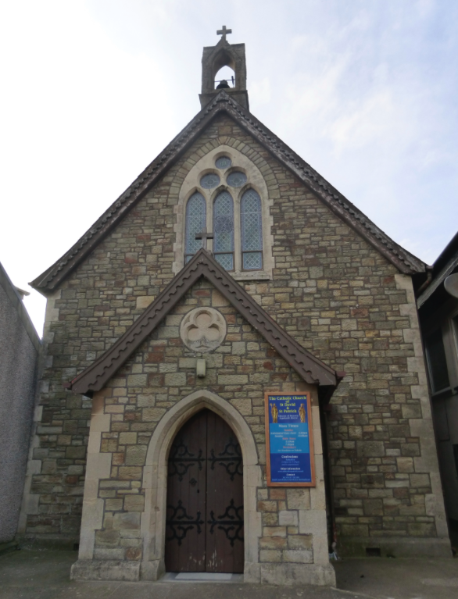 | St David and St Patrick’s Catholic Parish
 | St David and St Patrick’s Catholic Church,  9, Fountain Row, Barn Street,  Haverfordwest. SA61 1SX. | Immaculate Conception Catholic Church,  Church Street, Narberth.  SA67 7BH.
Parish Priest: Rev. Liam Bradley. Tel. 01437 762284
Parish email: stdavidandstpatrick@gmail.com
Website: www.stdavidandstpatrick.org
november
Mass times for 7th May – 13th May 2018th  The 6th Week of Easter, Year B.  Mon 10:00am No Mass.  Tue 2:00pm Mass at St Luke’s, Withybush Hosp.  Wed 10:00am Mass at H-west. 7:00pm Mass at Narberth (Vigil of tomorrow).  Thur 10:00am Mass at Haverfordwest. 7:00pm Mass at Haverfordwest. Solemnity of the Ascension.  Fri 10:00am Mass at Haverfordwest.  Sat 6:00pm Mass at Haverfordwest.  Sun 10:00am Mass at Haverfordwest,  5:00pm Mass at Narberth. | Saint of the Week – The solemnity of the Ascension of the Lord  This feast day can trace its roots back into antiquity, and is one of the oldest feasts of the Church. It celebrates the bodily departure of Christ from this world and his returning to the Father. The feast day falls 40 days after the celebration of Easter and may occur between April 30th (next occasion in 267 years’ time!) and June 3rd. Ten days after the Ascension, is the feast of Pentecost (50 days after Easter). The time between the two feasts is often dedicated to a specific prayer intention, which is prayed for nine consecutive days – this season of prayer is called a novena. Scenes of the Ascension are often a subject of art and are based on Biblical accounts found on Mark 16:19, Luke 24:51 and Acts 1:2. The Ascension took place from the Mount of Olives where a small domed chapel today stands

Funerals Please pray for the repose of the soul of Mrs Maureen Connelly who died recently at Withybush Hospital. Please also keep in your prayers Mr Grahame Daniels who died last Sunday. His funeral service will take place at Parc Gwyn Crematorium on Friday 18th May at 13:45pm. Eternal rest grant unto them O Lord, and let perpetual light shine upon them. May they rest in peace. Amen.

Fr Liam’s seminary visit This weekend I shall be with Bishop Tom at Oscott College, our seminary in Birmingham. One of our diocesan students – Robert Davies – is being appointed to the ministry of Acolyte. This is an important step on the way to priesthood. In my absence please welcome Fr Andrzej Kuklinski who will be celebrating the weekend Masses at Haverfordwest and Fr Michael Hart who will be celebrating Mass at Narberth.

Holy Day Following the recent decision of our bishops to return some of the holy days of obligation back to their original dates, so the Solemnity of the Ascension has returned to the traditional day of Ascension Thursday. As such, this day will be celebrated on three separate occasions, so as to facilitate the possibility that all will be able to get to Mass on this Holy Day. The Masses which will fulfill the obligation, and so further the devotion which we should seek to foster, are Wednesday evening at Narberth (a vigil Mass), Thursday morning at 10:00 at Haverfordwest (when we will be joined by Mary Immaculate School) and 7:00pm at Haverfordwest.

First Holy Communion On Saturday 12th May at 11am, our Parish will celebrate the First Holy Communion of many of our younger members. Please do keep them in your prayers as they make their final preparations for this occasion. I would like to offer a sincere thanks to those who have helped our younger members to prepare for this day, including the staff of Mary Immaculate School, our parish catechists who have supported those who go to other schools, and of course the parents and family members of those children who will be receiving Christ in the Eucharist. This annual event is one of importance to the whole parish so let us pray together that our younger members may continue to grow in their faith.

Pilgrimage to the National Shrine May 20th – the Solemnity of Pentecost – is the annual pilgrimage to the National Shrine of Wales, Our Lady of the Taper. The day commences with the Sacrament of Reconciliation at 1:30pm followed by the Rosary Procession at 2:30pm. Mass will be celebrated by the Bishop of Wrexham, Peter Brignall, at 3pm and the day will conclude with a Holy Hour ending with benediction and the blessing of the sick at 5:15pm. I would like to encourage as many who are able to attend.

Please pray for those who are ill Mercedes Davies, Hannah Fennell, Peter Fowler, Jeffrey Frank, Bryn Hancock, Anne Harding, Margaret Higgins, Janet Jenkin, Indra Singh, Ben Stabow, Teresa Thomas, Toby Williams, Kay Whelan.

