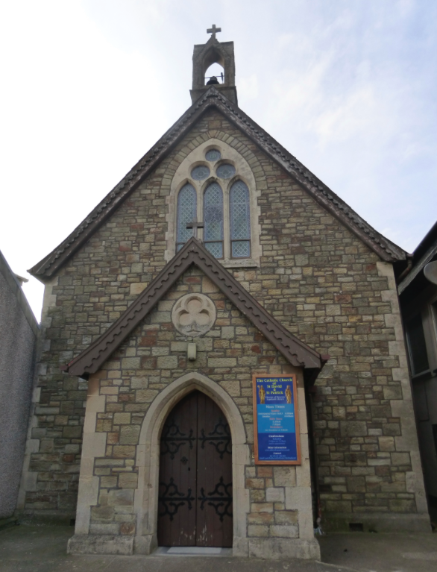 | St David and St Patrick’s Catholic Parish
 | St David and St Patrick’s Catholic Church,  9, Fountain Row, Barn Street,  Haverfordwest. SA61 1SX. | Immaculate Conception Catholic Church,  Church Street, Narberth.  SA67 7BH.
Parish Priest: Rev. Liam Bradley. Tel. 01437 762284
Parish email: stdavidandstpatrick@gmail.com
Website: www.stdavidandstpatrick.org
november
Mass times for 14th May – 20th May 2018th  The 7th Week of Easter, Year B.  Mon 10:00am Mass at Haverfordwest – St Matthias.  Tue 2:00pm Mass at St Luke’s, Withybush Hosp.  Wed 10:00am Mass at H-west; 7:00pm Mass at Narberth.  Thur 10:00am Mass at Haverfordwest.  Fri No Mass.  Sat 6:00pm Vigil Mass of Pentecost at Haverfordwest.  Sun 10:00am Pentecost Mass at Haverfordwest,  5:00pm Pentecost Mass at Narberth. | Saint of the Week – St Matthias the Apostle This apostle has a unique story in that he wasn’t chosen personally by Christ. Rather his choice as a replacement apostle for Judas came about between the Ascension and Pentecost, by a means of a ballot or casting lots. The community discerned Christ’s will by this method, which was left open to God’s providence to dictate. The story is mentioned in the Acts of the Apostles, and Matthias doesn’t feature in the Gospels. We know very little about him but there is some evidence that, after Pentecost, he traveled to Cappadocia and spread the Gospel in the area we today know as the edge of the Caspian Sea.
Funeral Please also keep in your prayers Mr Grahame Daniels whose funeral service will take place at Parc Gwyn Crematorium on Friday 18th May at 13:45pm. Eternal rest grant unto him O Lord, and let perpetual light shine upon him. May he rest in peace. Amen.

First Holy Communion This weekend our parish celebrated the First Holy Communion of eighteen boys and girls in a packed church. It was delight to see the parish looking so vibrant. Well done and congratulations to all those who have received this Sacrament. My heartfelt thanks also to those who have worked hard for the preparations involved in this great day – those who have been involved in the education of our younger members - both in the parish and in our School of Mary Immaculate; those who have decorated the church and hall; those who helped prepare the liturgy; and those who helped to tidy-up afterwards.
Pilgrimage to Our National Shrine in Cardigan Next Weekend, Sunday 20th May, the Solemnity of Pentecost, is also the annual pilgrimage to the National Shrine of Wales, Our Lady of the Taper. I normally would like to see our parish church full on that day but, if you are able, please also support the Shrine. The current Rector, Fr Harries, is trying to increase the use of the shrine and has encouraged every parish to send a representation. I will be attending for part of the day, and it would be lovely to see some of you there. The afternoon commences with the Sacrament of Reconciliation at 1:30pm followed by the Rosary Procession at 2:30pm. Mass will be celebrated by the Bishop of Wrexham, Peter Brignall, at 3pm and the day will conclude with a Holy Hour ending with benediction and the blessing of the sick at 5:15pm.
Happy Birthday Our retired deacon this weekend celebrates a significant milestone. Please do give Rev. Tony your best wishes on this significant anniversary (he’s 40 again!)
Caldey Island Trip Please save the date. On Saturday 16th June our Confirmation Class will be making a day pilgrimage to Caldey Island, and all the parish are invited to come along. Although weather dependant for the sailing, its normally a great day out to relax and enjoy all that the island has to offer – including our own barbecue in the monastic grounds. More information will follow soon.
Requests Does anyone have any no-longer-used teapots and bathmats? (an odd combination I know!) If so, they could be very useful. Please speak to Ann Harris after Mass, or simply bring your mats and teapots next weekend and leave them in the Sacristy.
Petition There has been much in the media recently about the support of women who a facing massive choices as to whether or not they should continue in pregnancy – support that has been offered outside medical centers. Now decisions have been made so that members of our church communities cannot engage in this activity, because some have construed our wanting to support families as violent protests against abortion (even though there is scant substantive evidence that any person has demonstrated violently). Our aims are always to pray for those who need support, to offer a listening and non-judgmental ear to those who are seeking help, and to open to them the possibility of keeping their child who has a right to life. SPUC have organized a petition to allow Christian men and women to once more be allowed the freedom of speech to talk openly outside medical clinics. The petition can be found in the porch.
Pentecost Next Sunday is the feast of Pentecost when the Church throughout the world celebrates the descent of the Holy Spirit on Christ’s followers and the birthday of the Church. Please feel free to dress in national costume or to wear Red, the liturgical colour of the day. Also, we hope to have a party in the hall after Mass so please do bring something enjoyable to share such as a plate of food, or something to drink!
GDPR - Data Protection Law. More information on this will follow soon as the law changes later this month concerning how the diocese keeps personal information secure. Please note that from May 25th the parish will have a new email address haverfordwest@menevia.org

Please pray for those who are ill Mercedes Davies, Hannah Fennell, Peter Fowler, Jeffrey Frank, Bryn Hancock, Anne Harding, Margaret Higgins, Janet Jenkin, Indra Singh, Ben Stalbo, Teresa Thomas, Toby Williams, Kay Whelan.

