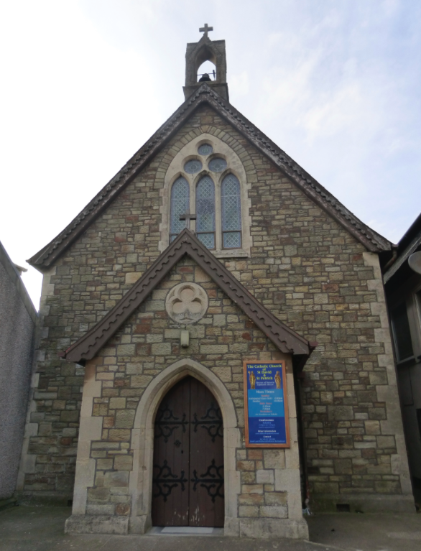 | St David and St Patrick’s Catholic Parish
 | St David and St Patrick’s Catholic Church,  9, Fountain Row, Barn Street,  Haverfordwest. SA61 1SX. | Immaculate Conception Catholic Church,  Church Street, Narberth.  SA67 7BH.
Parish Priest: Rev. Liam Bradley. Tel. 01437 762284
Parish email: see below.
Website: www.stdavidandstpatrick.org
november
Mass times for 14th May – 20th May 2018th  Pentecost Year B, then 7th Week of Ordinary Time, Year II.  Mon 10:00am Mass at H-west – Mary Mother of the Church.  Tue 2:00pm Mass at St Luke’s, Withybush Hosp – St Rita of Cascia.  Wed 10:00am Mass at H-west; 7:00pm Mass at Narberth.  Thur 7:00pm Mass at H-west – Feast of Jesus Christ, Eternal High Priest.  Fri No Mass – St Bede the Venerable.  Sat 6:00pm Mass at Haverfordwest.  Sun 10:00am Mass at Haverfordwest,  5:00pm Mass at Narberth. | Saints of the Week – There are two new days in the Roman Calendar which will be celebrated this week – see below for more information. In addition we celebrate St Rita of Cascia, an Augustinian mystic and stigmatist (1381-1475) who took up religious life upon the murder of her husband. She offered her devotions so as to dissuade her sons from revenge. St Bede the Venerable is an English saint from Northumbria (672 – 735) who was a monastic and is noted for his literary works. His texts are important still to both the Church and academic study. In 1899, Pope Leo XIII award him the title of Doctor of the Church. On Saturday is the memorial of St Philip Neri who was born at Florence in 1515 and became known as the Third Apostle of Rome after Sts Peter and Paul. He was a founder of the Congregation of the Oratory and spent most of his life in Rome
Pilgrimage to Our National Shrine in Cardigan This weekend is the Solemnity of Pentecost, is also the annual pilgrimage to the National Shrine of Wales, Our Lady of the Taper. The current Rector, Fr Harries, is trying to increase the use of the shrine and has encouraged every parish to send a representation. I will be attending for part of the day, and it would be lovely to see some of you there. The afternoon commences on Sunday with the Sacrament of Reconciliation at 1:30pm followed by the Rosary Procession at 2:30pm. Mass will be celebrated by the Bishop of Wrexham, Peter Brignall, at 3pm and the day will conclude with a Holy Hour ending with benediction and the blessing of the sick at 5:15pm.

Baptisms This weekend we welcome Rose Mai and Norah Olivia Haworth to our parish community as they are baptized. May they continue to grow in their faith as they become part of the family of the church. The next baptism preparation day takes place on the 2nd June at 10am, for those who have booked their place. The following preparation day will take place on the 15th September and if you’re expecting a child, or have recently given birth, then please make contact with Fr Liam to book a place on this day. To receive the Sacrament of Baptism the parents of the child/children must attend a preparation day and show their commitment to the parish by attending Masses.

GDPR - Data Protection Law. More information on this will follow soon as the law changes later this month concerning how the diocese keeps personal information secure. The clergy are soon to meet with the diocesan solicitor for a briefing, as to how the new laws will affect the parish. Each parish is a constituent part of the Menevia Diocesan Trust, charity number 234168. It is likely that most of the records kept in the parish will be archived or destroyed and that your consent for the parish to keep personal contact information will need to be re-acquired. This gives us the opportunity to conduct a parish census and to set-up the possibility of receiving newsletters in an electronic format, for those who wish. Please note that from May 25th the parish will have a new email address haverfordwest@menevia.org and the old email address will be closed. There are many in the parish who also use my personal email address (which starts revliambradley@....) and many have my mobile telephone number also. Please may I ask all to no longer use these as methods of contact and to remove them from your address books; I will no longer be replying to any parish business on these media. To contact me please use the office telephone or the new email address. Under the new laws, if I have a parishioner’s contact details in my mobile phone, and that phone is stolen or lost, I am liable to be fined for the loss of data, even if that data is never accessed. As such I shall be reviewing my address book and removing the contact details of anyone who is known to me in my capacity as a priest.

Irish Referendum As the people of Ireland get ready to go to the polls this week to vote on the 8th Amendment, so the Bishops’ Conference of England and Wales have asked all of us to pray for the people of Ireland. Perhaps on May 25th we could all spend a moment to pray for our Irish brothers and sisters. “Let us pray that the Holy Spirit will guide the people of Ireland with wisdom and courage in the forthcoming referendum. In all circumstances may they show love and care for children and their mothers. Lord, hear us.”

Feast Days and Mass Times There are two new days which have been added to the Church’s calendar and both are celebrated this week. The first is on Monday whereby we keep the memorial of Mary, under her title of the Mother of the Church. The second celebration is the Feast of Our Lord Jesus Christ the Eternal High Priest. On this feast Mass will be celebrated at 7pm at Haverfordwest. More details as to the nature of these celebrations will be given at the respective Masses.

Confirmation Owing to conflicts in the bishop’s diary, we have had to change the time of Confirmation. The Celebration of Confirmation will now take place on Evening of Saturday June 30th, the evening before the previously advertised date.

Please pray for those who are ill Mercedes Davies, Hannah Fennell, Peter Fowler, Jeffrey Frank, Bryn Hancock, Anne Harding, Margaret Higgins, Janet Jenkin, Indra Singh, Ben Stalbo, Teresa Thomas, Toby Williams, Kay Whelan.

