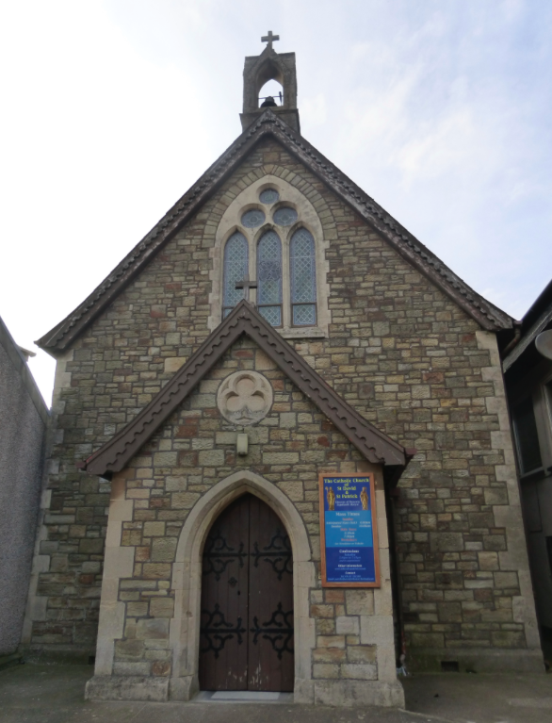 | St David and St Patrick’s Catholic Parish
 | St David and St Patrick’s Catholic Church,  9, Fountain Row, Barn Street,  Haverfordwest. SA61 1SX. | Immaculate Conception Catholic Church,  Church Street, Narberth.  SA67 7BH.
Parish Priest: Rev. Liam Bradley. Tel. 01437 762284
Parish email: haverfordwest@menevia.org
Website: www.stdavidandstpatrick.org
november
Mass times for 28th May – 3rd June 2018  Trinity Sunday, then 8th Week of Ordinary Time, Year II.  Mon 10:00am Mass at Haverfordwest.  Tue No Mass  Wed 10:00am Mass at H-west; 7:00pm Mass at Narberth.  Thur 10:00am Mass at Haverfordwest – Visitation of the Blessed Virgin Mary  Fri No Mass – St Justin Martyr.  Sat 6:00pm Mass at Haverfordwest.  Sun 10:00am Mass at Haverfordwest,  5:00pm Mass at Narberth. | Saints of the Week – The Visitation of the Blessed Virgin Mary recalls the event of Mary, who having just conceived Jesus Christ, goes to visit her cousin Elizabeth, who is pregnant with John the Baptist. We find the story in Luke’s Gospel, Lk 1:39-56. Upon greeting each other, the two babies leap for joy and Mary prays the ‘Magnificat’. This ancient prayer comes from the lips of Hannah who makes a similar prayer to the Lord in thanksgiving for the birth of Samuel. Her words are found in 1 Samuel 2:1-11. To this day, the Magnificat is sung by clergy and religious every evening as part of Vespers, and many composers have fitted music to the text.

Baptisms The next baptism preparation day takes place on the 2nd June at 10am, for those who have booked their place. The following preparation day will take place on the 15th September and if you’re expecting a child, or have recently given birth, then please make contact with Fr Liam to book a place on this day. To receive the Sacrament of Baptism the parents of the child/children must attend a preparation day and show their commitment to the parish by attending Masses.

Funeral Of your charity, please pray for the repose of the soul of Mr Joseph Myrane who died at Withybush hospital recently. His private funeral service will take place in our church later this week.

Council of Clergy Meeting Fr Liam will be unavailable all day on Tuesday as he meets with the bishop and all the clergy of the diocese. The council of clergy meeting is when the bishop and his offices (education office, estates office, financial office etc) get together to brief the clergy with updates and when the clergy get to raise points of discussion. Please do keep the clergy of the diocese in your prayers that day and as we plan for the future.

Sick and Retired Clergy Please forgive me for not advertising this second collection last week for the sick and retired clergy of our diocese. The collection was supposed to take place this weekend. However, given the lack of advertising, it would seem unfair to expect a second collection with no warning. As such I shall postpone the collection to next weekend.

Confirmation Owing to conflicts in the bishop’s diary, we have had to change the time of Confirmation. The Celebration of Confirmation will now take place on the evening of Saturday June 30th, the evening before the previously advertised date.

Welcome This weekend we welcome Fr Alexander MacDonald to our parish. Fr Alexander was a student with me in Rome and was ordained just two weeks ago as a priest for the Diocese of Toronto in Canada. Prior to him taking up an appointment as Curate in his Cathedral, he’s having a few weeks vacation to visit friends and Holy sites in Europe. Having visited the Holy Well at St Non’s, his next stop is Lourdes. Feel free to tell him any prayer intentions you may have as he will light a candle at the shine for the prayers of our parish.

Papal Document You may have seen in the press recently that Pope Francis has published a new apostolic exhortation (his 3rd to date) entitled Gaudate et Exultate (Rejoice and be Glad) on the call to holiness in today’s world. This short text is well worth a read as Pope Francis encourages us all to come closer to Jesus, who wants all of us to become saints – a goal which is not beyond us! A free copy of the text is available from the Vatican website http://w2.vatican.va/content/francesco/en/apost_exhortations/documents/papa-francesco_esortazione-ap_20180319_gaudete-et-exsultate.html

Please pray for those who are ill Mercedes Davies, Hannah Fennell, Peter Fowler, Jeffrey Frank, Bryn Hancock, Anne Harding, Margaret Higgins, Janet Jenkin, Indra Singh, Ben Stalbo, Teresa Thomas, Toby Williams, Kay Whelan.

